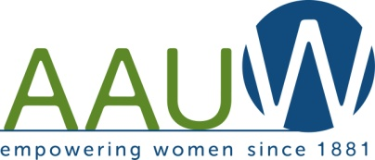
Midland Branch Newsletter ~ January 2019
The Twig

AAUW advances equity for women and girls through advocacy, education, philanthropy and research.
Coffee & More
Focus on Title IX in Midland
Thursday, January 17, 2019, 10:00 am
Grace A. Dow Library Community Room
Our January program will start 2019 with our minds focused locally on the Midland Public Schools. Title IX is a major focus for AAUW nationally, so we have invited Cynthia Marchese, Title IX Coordinator for the Midland Public Schools, to be our guest speaker. Title IX has evolved since its inception in 1972. Today, Title IX protects all students from discrimination in educational programs and activities – students of all genders, from kindergarten through college. Perhaps like me, you know Title IX exists, but have limited understanding of how it is implemented, especially locally. After 47 years, what does Title IX look like? How has it changed since its inception? How is it helping our students here in the Midland Public Schools? Cynthia Marchese will share her knowledge and learnings with us.
Understanding Title IX is important to all of us, especially right now. The Department of Education has issued a plan to make sweeping changes to Title IX’s regulations, which could have significant implications for students’ civil rights and for federal enforcement of the law. Will this strengthen or weaken Title IX protection? Unless we increase our personal understanding of Title IX, it will be difficult to form an educated opinion on the proposed changes.
We look forward to seeing you for coffee & more. Remember guests are always welcome.

President’s Message ~ Mary Crane-Franek
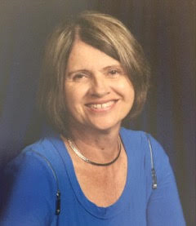
My wish is that 2019 be a year of warm memories for each of you and for our branch. For AAUW and AAUW Midland Branch to continue its mission, we need all members to think how they can help support AAUW, especially locally. The Branch nomination committee is currently busy filling the slate for new officers for 2019-21. As the year progresses, other positions will, most likely, need to be filled as standing committee chairs and project committee chairs positions become vacant. I already know we need a new HELPS Editor.
Please open up your hearts and minds when you are asked to consider taking an active role in the AAUW Midland Branch. You will find it a rewarding experience. Thank you for all your past efforts in making our branch successful and for the future success of our branch.
Mary

Leaders of Tomorrow ~ Send Them to NCCWSL
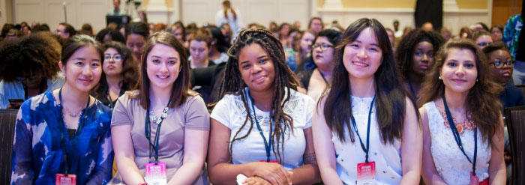
Carol Hoerneman Plaush ~ College /University Liaison
The AAUW National Conference for College Women Student Leaders is the premier conference for students to hone their leadership skills, make lifelong connections, and get ready to shape the world.
The female leaders of tomorrow are being shaped right now. Do you know a college woman who would benefit from attending the National Conference for College Women Student Leaders (NCCWSL) in 2019? The conference dates are May 29 to June 1, 2019 at the University of Maryland, College Park, Maryland.
Our Midland Branch must be ever vigilant to notice and encourage today’s young college women to dream big and take advantage of the NCCWSL Leadership Scholarship that we offer. Our past experience sending local students to NCCWL has proven to us the value of the experience. One recipient told us “NCCWSL was a phenomenal experience. Each day I was surrounded by encouraging professionals and empowering females. I’d like to thank AAUW from the bottom of my heart for giving me an experience I will never forget.”
Deadline to apply for the scholarship is January 29, 2019. All the information for this scholarship is on the application form found on the Midland AAUW website https://midland-mi.aauw.net.

Membership
LuEllen DeLine, 2nd VP Membership
Thank you for renewing your AAUW Midland Branch membership. At the National level, the Membership Committee challenged us to renew 90 percent of all branch members. Midland Branch met the challenge with a 90% renewal. That is a great response, but sadly we have lost 8 members for various reasons.
Recruitment is the next big priority for our branch. Inviting guests to our general meetings is a great way to introduce prospective members to AAUW. The “Shape the Future” campaign is still active. Recruit a new member at the meeting and their national dues are reduced by 50%.

Mark Your Calendar
January 17, Thursday, 10:00 am Library Community Room
February 14, Thursday, 10:00 – 12:00 am Mid-MI Hospital - Advanced Care Planning Specialist
March 21, Thursday, 10:00 – 1:00 pm Library Community Room, Annual Meeting
April 26-28, Used Book Sale, Midland Mall
President: Mary Crane-Franek ~ 1st VP Program: Chris Ferrando
2nd VP Membership: Lu Ellen DeLine ~ The Twig Editor: Pauline Pittsley
Web sites: https://midland-mi.aauw.net https://aauwmi.org/ E-mail: aauwmidland@gmail.com

