Previous AAUW Midland Branch NCCWSL Scholarship winners from the Great Lakes area are Sara Chase, Scout Parsch, & our
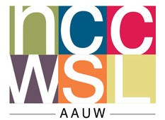
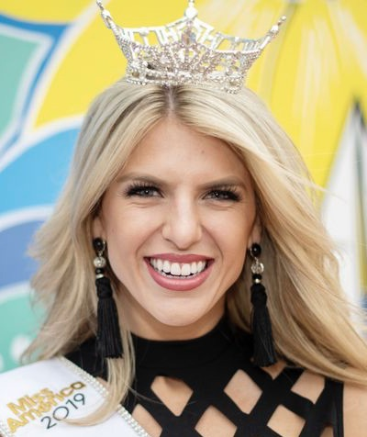
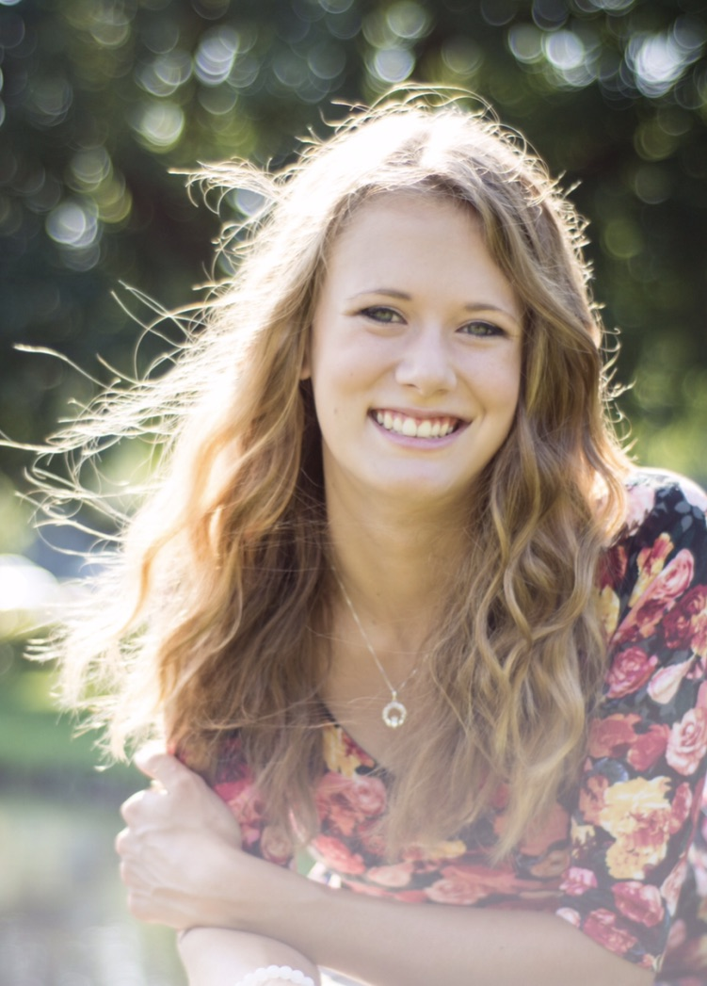
2019 Miss Michigan Mallory Rivard!
AAUW Scholarship of $1,500 is available to Attend NCCWSL, the National Conference for College Women Student Leaders May 29---June 1, 2024
The American Association of University Women (AAUW)—Midland Branch is offering scholarship assistance for two college/university women to attend the National Conference of College Women Student Leaders (NCCWSL) to be held May 29,--JUNE 1, 2024 at the University of Maryland, campus at College Park, Maryland.

Two $1,500. Scholarships will be offered. Scholarship applicants should have a 3.0 GPA, either be attending a local college/university, or be from the area & attending college elsewhere. The Awards process includes an application with a short essay, a recommendation from a college/university official or faculty member, and a list of college & community activities noting any leadership roles held. A brief oral report of the experience is expected to be presented at an AAUW—Midland Branch meeting during the 2024/2025 program year.

Please find the Application form for this scholarship on the next page and
Midland (MI) Branch AAUW website
https://midland-mi.aauw.net/scholarships/nccwsl/
or email Carol Hoerneman Plaush at cchp43@gmail.com

Application Deadline is Tuesday January 30, 2024
The Conference will help students develop leadership & Networking Skills. It is presented by AAUW & NASPA’s Center for Scholarship, Research, & Professional Development for Women. More than 1,000 women from around the United States attended last year. AAUW promotes equity, education, & development of opportunity for women & girls that enable them to realize their full potential.
All information about this scholarship is found on the Midland AAUW website https://aauw-midland-mi.aauw.net
or email Carol Hoerneman Plaush at cchp43@gmail.com
Application Deadline is Tuesday January 30, 2024
AAUW Midland (MI) Branch, Inc.

Application for a scholarship to attend the 2024 NCCWSL
National Conference of College Women Student Leaders
(Completed application is due no later than Tuesday January 30, 2024 to cchp43@gmail.com
Sponsored by AAUW the American Association of University Women and NASPA’s Center for Scholarship, Research, and Professional Development for Women.
The National Conference for College Women Student Leaders, NCCWSL will be held
May 29---JUNE 1, 2023 on the campus of the University of Maryland, College Park, Maryland. Nearly 1,000 college Women attended the 2020 conference that included exciting keynote speakers, approximately 50 dynamic workshops and presentations, recognition of the 2020 Women of Distinction, plus networking opportunities & community service options.
Scholarship winners will be asked to apply to AAUW for a National Scholarship. You may not get the award but you will get a discount on the cost of the registration just for applying for the National Scholarship. The Midland Branch Award will cover the rest of the registration, lodging, extra nights, optional activities, airfare, local transportation. & non conference meals. (Because you will apply for the National Scholarship, DO NOT fill out a separate registration.) The total award (National & local) will be a maximum of $1,500.
Criteria:
* A currently enrolled female student with a minimum 3.0 GPA.
* An essay-one page, typed, double space, 400-500 words which addresses two points- describe:
1. A leadership or service activity that has inspired you to take advantage of this
opportunity. 2. And how you plan to utilize this leadership experience in future activities.
* A recommendation from a college/university official or faculty
sent directly to the email or address below.
* A separate list of college and current community activities noting any leadership roles.
* A report of your experience to AAUW-Midland Branch during the 2024 program year.

First Name____________________Middle ____Last Name_________________________

Street address_________________________________phone__________________________

City____________________________Zip__________Parent’s Name____________________

Home Address**:_______________________________________________________________

Email________________________________________Major(s)________________GPA__

College/University_____________________Yr in college__Fr__So__Jr__Sr__Grad
**Priority consideration will go to a student in Midland County.
Please consult the following web site for more conference information: www.aauw.org/nccwsl/
Note: By accepting this award you give permission to AAUW-Midland Branch to use your name & photo in newspaper or web articles describing the event as part of efforts by AAUW to promote the program & to raise additional scholarship funds.

Applicant Signature_____________________________________________________date_________________________
Completed application is due no later than Tuesday, January 30, 2024 to cchp43@gmail.com or
Carol Hoerneman-Plaush AAUW-Midland Branch, 4202 Chelsea Ct, Midland, MI 48640

