Used Book Sale by Trudy Dutot

The Used Book Sale will be held on April 26, 27, and 28, 2024. We expect to collect well over 10,000 books so we require a big team of workers. Over the years, we have developed a very smooth system to sort and categorize books and media materials. New team members are always welcome. Please take part to help raise funds for scholarships for local women. Our AAUW Branch will award up to $16,000 in scholarships this spring.

The sort room is the old calendar store next to the mall office. Barrels will be out Friday, March 29th and the sort room is open Monday, April 1st.

You can also help by spreading the word about the sale. We need many buyers to achieve the sale income needed to support our scholarships. Hope to see you there!
Your help is important. We welcome spouses and friends to help in this endeavor. We need help in the following ways:

- Pick up donated books from grocery stores some days
- Put price stickers on books and put them in category boxes
- Stack books on sale tables Thursday evening, April 25th
- Take a 2-hour shift at the sale, selling or keeping tables straightened
- Help box books for gifting and recycling at the end of the sale
To volunteer, please contact Pauline Pittsley at 989-430-2067 or Pauline@drymud.com

February General Meeting is a Success by Chris Ferrando

Our February General Meeting speaker, Bertha Vaughn, gave an outstanding presentation on how she used education as her tool to journey from the “Jim Crow” South to a full-time job at The Dow Chemical Company. A record attendance of 45 people attended this meeting. Photos were captured by Carol Arnosky.

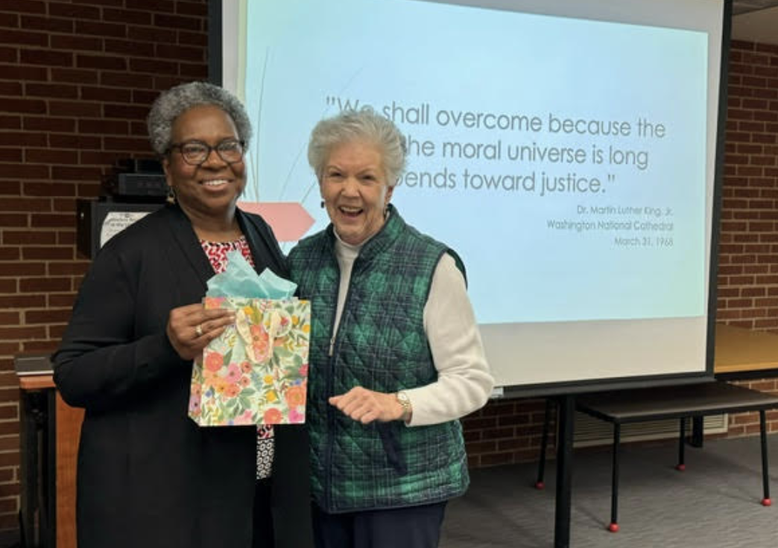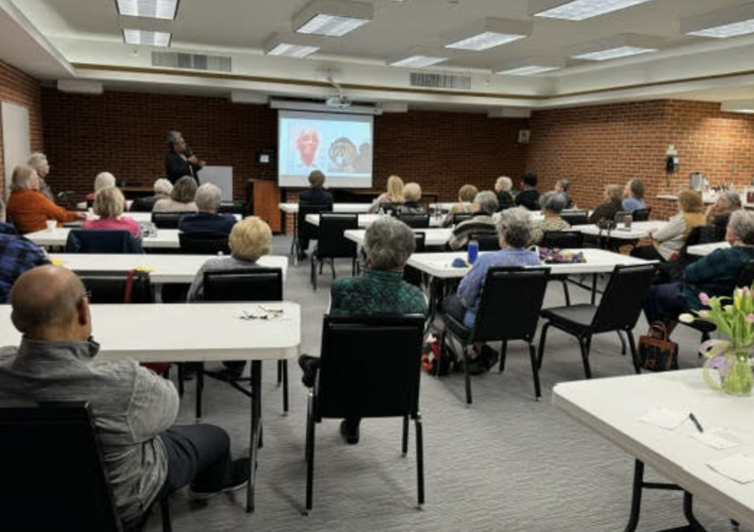
Chris Ferrando giving our thanks to Bertha Vaughn A snapshot of our record-breaking attendance
The speaker for the March General Meeting is pending.
Information will be sent via email as soon as it is available.

President’s Message by Carol Arnosky

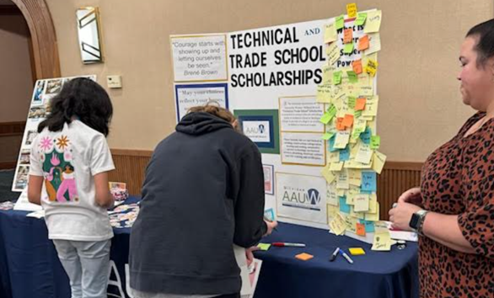
March is National Women’s History Month, but since women are pretty historic year-round, it begs the question: Why March? Some of the important events that occurred in this month: Title IX passed the Senate on March 1, 1972; Equal Rights Amendment passed the Senate on March 22, 1972 (still not ratified); the first major suffragist parade in Washington DC was held on March 2, 1913; National Woman’s Party was officially formed in March 1917; International Woman’s Day is March 8, 2024; Women’s Equal Pay Day is March 12, 2024. “March” is an appropriate month, as demonstrations and public displays were/are an important part of what we do.

Judi Cox and I had an AAUW table at the recent “Build Like A Girl” event, held at the Great Hall, to talk about our Trade and Technical Scholarships. The purpose of this annual event is to introduce young women to career opportunities in the construction industry. The girls wrote their Super Powers on sticky notes, picked up empowerment stickers, learned about our book sale, and the scholarships. Judi and I enjoyed talking to the girls and their ‘chaperones’. The AAUW display at the “Build Like A Girl” event

Branch Officers to be Elected at the March Annual Meeting by Ruth Copp & Barb Galloway, Nominations Committee
The Nominations Committee, consisting of Ruth Copp, Judi Cox, Chris Ferrando, Barb Galloway, Liz Kapla, and Pauline Pittsley, extends their appreciation to the following candidates for the slate of officers for 2024-2026.

President (2024-25): Carol Arnosky
Carol joined AAUW in 2015. She is a graduate of Florida State University with a degree in accounting and received her MBA from the University of Houston. She worked for 25 years as an accountant/finance analyst for Tenneco Oil Company and the Dow Chemical Company. After retiring, Carol was the owner of Scrapbooks Galore & More for ten years. She has served as the Midland Branch’s President for the past four years, has been Communications Officer and participated in many interest groups: Done in a Day, Gardening for Fun, Shelterhouse Birthdays, Matinees & More, and the Used Book Sale. Being active in her community is a priority for Carol and she volunteers for numerous causes. Carol and her husband, Steve, have three children and three grandchildren. They frequently travel to Texas, Illinois, and Missouri to enjoy these offspring.
Finance Vice-President (2024-26): Liz Kapla
Liz joined AAUW in 2005 and has served as Finance Vice-President for the past 7 years, she has been on the Program Committee, the Nominations Committee, Shelterhouse Birthdays Committee, and works on the Used Book Sale. She received her B.S. in elementary education at the University of Colorado. She taught in Boulder and then Freeland, after moving to Midland. After raising four children with her husband, she created and ran the Midland Mentors program for at-risk teens at the Midland County Probate Court. Liz enjoys volunteering, gardening, reading and traveling - especially to visit her children and grandchildren who live in Washington D.C., Seattle, Wiesbaden, Germany, and Colorado Springs.
Nominations Officer (2024-25): Pauline Pittsley
Pauline has been a member of AAUW for 38 years. During that time, she has served the branch in many capacities including President, VP/Program Development, Communications Officer, Women’s Issues Luncheons Chair, TWIG Editor, and Handbook Editor. She chaired the Used Book Sale for a number of years and continues to help manage the sale. She graduated from SVSU with a teaching degree and taught in Bay City Public Schools before moving to Midland. Pauline is retired from Senior Services where she was the Volunteer Manager and editor of the Senior Independence Newspaper. Her personal interests include the creative arts, cooking, and reading.
Delegate-at-Large (2024-25): Mary Harding
Mary joined AAUW in 2021. She was born and raised in Midland. She then attended Oakland University and graduated with a Bachelor of Science degree from Central Michigan University. She lived in Rochester Hills for 25+ years and moved back to Midland to be around family. Mary currently works for MyMichigan Health in the Patient Financial Services Department and has over 30 years’ experience in medical insurance and hospital policy and procedure. Her volunteer experience includes the Midland Center for the Arts, Tri-City Brewing in Bay City, and Election Inspector. Her first experience of being on a committee was Adams Elementary Student Government. She was appointed by her first-grade teacher, Deb Kaiser. Mary looks forward to continuing her community involvement by furthering the positive impact AAUW has on women and the community at large.
Recording Secretary (2024-26): Jane Wirth
Jane has been an AAUW Midland Branch member for 52 years which has included service as President, Co-President, Used Book Sale Chair, Treasurer, AAUW Funds, College/University Liaison, and several other branch offices and committees. She was instrumental in establishing the branch scholarships for the National Conference for College Women Student Leaders (NCCWSL) plus serving on the steering committee for a branch-sponsored area Transitions Conference. She is an Honorary Life Member of AAUW and a branch Named Gift Honoree. Jane received a BS in Home Economics Education from Iowa State University and taught for 5 years.

Mark Your Calendar

March General Meeting – details coming soon

April 26-28, 2024– Book Sale at the Midland Mall
May 11, 2024 – 2024 Statewide Convention at the Detroit Marriott, Livonia

President: Carol Arnosky 1st VP Program: Chris Ferrando
2nd VP Membership: Judi Cox The Twig Editor: Annette Clapp

Websites: https://midland-mi.aauw.net https://aawumi.org/ E-mail: aauwmidland@gmail.com

