|  |
| --- |
|  |

** December General Meeting**

**Thursday, December 19, 2024**

**Midland Country Club – Ballroom C**

**11:30 am - 1:30 pm (handicap accessible)**

**‘Tis the Season**

The Program Committee is inviting all members and their guests to come and enjoy the AAUW Holiday Luncheon on Thursday, December 19th at the Midland Country Club. Our lunch will consist of a sunburst fruit and chicken salad, slice of fruit bread, bread basket, nonalcoholic beverages, coffee, and tea.  Dessert will be peppermint sundae pie. The cost of lunch is $20.00 per person.  So mark your calendar and bring a friend and enjoy ‘Tis the Season.  Reservations are required by December 17th.  Make checks payable to AAUW Midland Branch.  Send to Liz Kapla,1205 Bayberry Lane, Midland, MI 48640. Contact Liz at [ekapla@charter.net](mailto:ekapla@charter.net) or at 989-631-7365.

The Midland County Emergency Food County Network (EFPN) does wonderful things for community members and this meeting is our chance to help them.

During this Season of Giving, Midland’s three Food Pantries are experiencing an increase in volume. This year, the Program Committee decided to give to the **Midland County Emergency** **Food County Network (EFPN**).  You can make your check out to EFPN and either bring it to the December General Meeting or send it to Liz Kapla. Liz will present our branch donations to EFPN.

Wishing all AAUW members Happy Holidays!

Branch Program Committee: Chris Ferrando, Barb Galloway, and Liz Kapla

|  |
| --- |
|  |

**President’s Message** by Carol Arnosky

Happy December & Happy Holidays to everyone!  I hope you have a wonderful time with family and friends, and that you land on Santa's "nice" list.

I was very pleasantly surprised to be the recipient of the 2024 Named Gift Honoree award for Midland branch.

I am honored to receive this award and would like to extend my heartfelt thanks to everyone involved in the selection process.  Thank you for recognizing my contributions and for inspiring me to continue striving to make our branch the best it can be.  I also appreciate all of our members with whom I have worked over the years.  You all Rock!!

I am looking forward to seeing all of you, with our best Christmas sweaters, at our December meeting!

**Time to Take Action: The Equal Rights Amendment Needs to Finally Be Added to Our Constitution**

by Jane Wirth, Public Policy

I know this is a busy time of the year, BUT take five minutes very soon to find the AAUW Two-Minute Activist site and send an urgent message to our Michigan Representative in Congress. As the AAUW website states: It has been a century since the Equal Rights Amendment (ERA) was introduced, and despite some progress, women’s equality is still at risk due to fluctuating legislative decisions. Without the ERA in the U.S. Constitution, advances in women’s rights that we took for granted are at risk of being weakened or even reversed. Waiting a century for over half of the U.S. population to attain constitutional equality is long enough. Tell Congress, not one more year!



AAUW makes it easy to take action. Go to aauw.org, click on “Take Action” and among the options that will appear is “Two-Minute Activist.” Click on that option, then scroll down to “Affirm the Equal Rights Amendment”, then choose “Take Action Now.” You will need to fill out a bit of information about yourself so that the email note at the bottom of that section will be directed to the proper person that represents you. You can accept the message as is or add or delete content in the message.

I found two errors I decided to correct:

* In the third paragraph, 3rd line—add the word “be” between or and difficult to read ”…back or be difficult”…
* In the fifth paragraph, 1st line—add an “o” to “flor” to read “floor”.

Then you can add a personal message anywhere you wish. I’m adding this line just before the line that starts “Thank you…”: Urge your reluctant colleagues to step forward to assure women’s equality in the United States. It’s time! Your mother, sister, daughter, granddaughter, or niece and women everywhere deserve this action without further delay.

P.S. While you are on the Two-Minute Activist site, check the other options for action and send another message to Congress. It’s easy, isn’t it?

|  |
| --- |
|  |

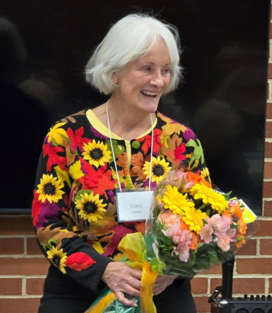

**Named Gift Honoree Award**

by Barb Galloway

Our President, Carol Arnosky, recently received the 2024 Named Gift Honoree award at the November 21st general meeting. This award is given annually, recognizing a member who has given generously of her time and her talents to our branch and to her community. One thousand dollars will be donated in her name to the AAUW fund of her choosing. Congratulations to Carol who is so deserving of this award.

Carol Arnosky receiving her Named Gift Honoree award