Our branch was treated to a very interesting talk by Jordan Dice, entrepreneur and owner of the Midland Mall, St. Laurent Brothers candy and nut shop as well as his most recent purchase, the State Theater in Bay City. He talked about his journey (His first job was at 14 when he started what he calls his first real business with StarNet Wireless). He has worked hard and learned about many businesses, which has culminated in his ownership, at his current age of 34, of these amazing and potential-laden properties. Our members asked many questions and provided positive feedback on everything from mall walking to the new parking lot and a shout out to the mall geese.

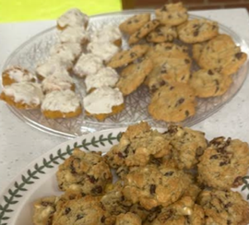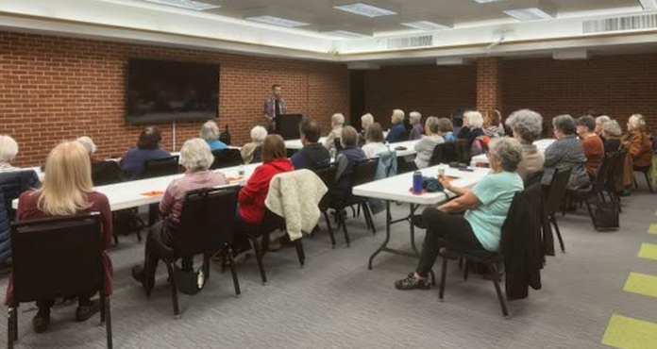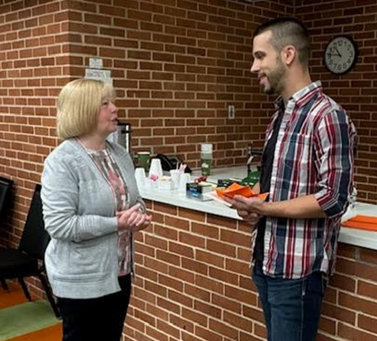Jordan Dice said it is hard to tell what the future holds. He does not have immediate plans to acquire anything new – his hands are full as it is with his current assets. We know he will succeed in whatever he does, and we appreciate him coming to talk to us.

Many members joined to hear what Jordan had to say

These cookies were handmade by the Program Committee

Trudy Dutot, our Used Book Sale Coordinator, talked to Jordan to let him know how much we appreciate the mall and to put in a good word for next sale in May 2025.

|  |
| --- |
|  |

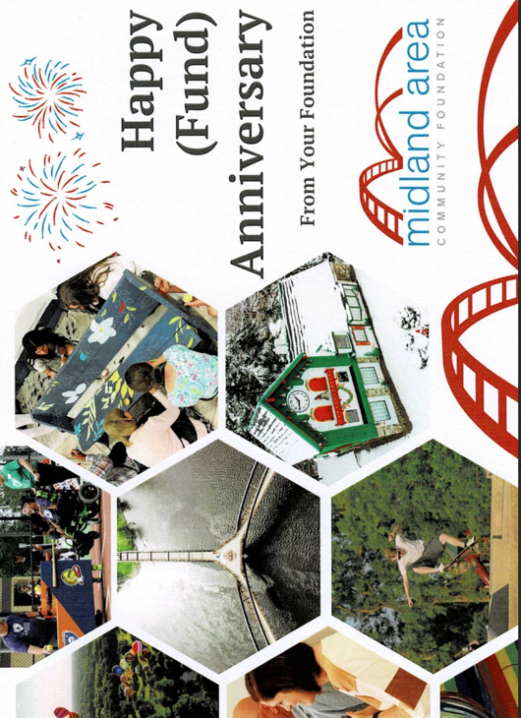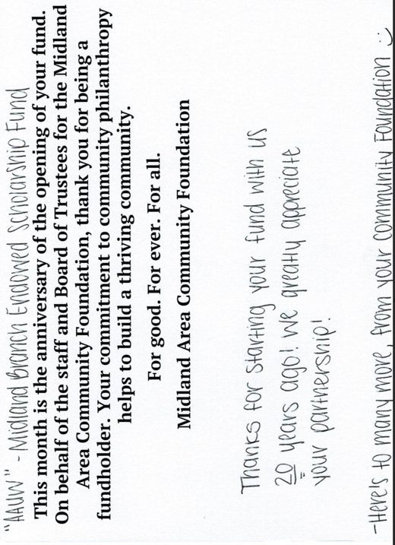**Thanks from the**

**Midland Area Community Foundation**

**The Passing of Maria Sablo-Yates** by Carol Arnosky

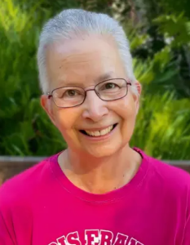It is with profound sadness that we share the news of the passing of our dear friend and valued member of the AAUW Midland Branch, Maria Sablo-Yates.

Maria was a very active member of AAUW and served on the Board of Directors and as President. She was an integral part of the Book Sale Scrub team for a very long time, and helped define the procedures for the Children's book sort area. Her influence and guidance are still in place today.

 Maria graduated from the University of Washington (Seattle) with B.A. and M.A. degrees in Spanish Language and Literature. As a lifelong educator, she taught at Central Michigan University and Delta College, where she was an Associate Professor of Spanish prior to her retirement.

She was a great person and will be gratefully missed by all that knew her.

In lieu of flowers, the family has asked that donations be made to Delta College in support of International Travel Scholarships.

Maria Sablo-Yates

May 4, 1952 – November 22, 2024

|  |
| --- |
|  |

**Mark Your Calendar**

December 19, 2024 – 11:30 am – 1:30 pm – December General Meeting

May 2-4, 2025 – Used Book Sale at the Midland Mall

President: Carol Arnosky 1st VP Program: Chris Ferrando

2nd VP Membership: Judi Cox The Twig Editor: Annette Clapp

Websites: <https://midland-mi.aauw.net> <https://aawumi.org/> E-mail: aauwmidland@gmail.com